CS23110 | G3 | Areeba Khan
Task 1: Write a script to generate a continuous time sinusoid signal with amplitude=2 for
a time 0 to 1 sec and taken the frequency as a user input by using input command.
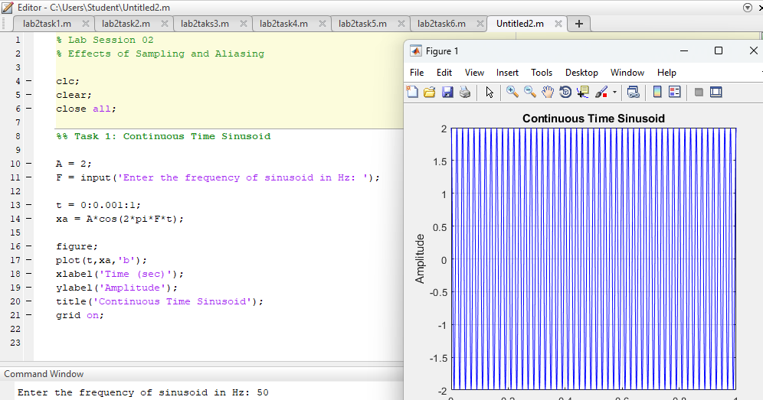
Task2: Write a script to convert continuous time signal of task#1 to a discrete time signal
and take the sampling frequency as input which should be less than twice the maximum signal
frequency in Hertz.
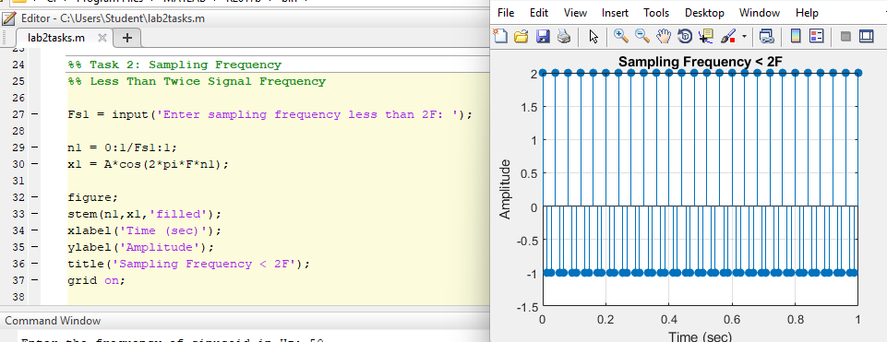

Task3: Write a script to convert continuous time signal of task#1 to a discrete time signal
and take the sampling frequency as input which should be equal to twice the maximum signal
frequency in Hertz.
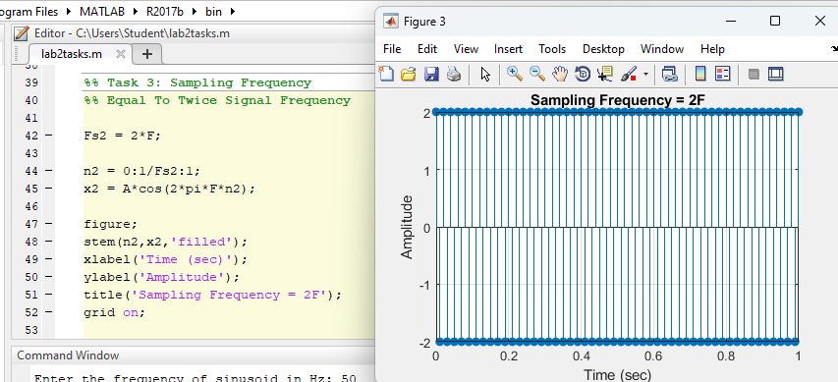
Task4: Write a script to convert continuous time signal of task#1 to a discrete time signal
and take the sampling frequency as input which should be greater than twice the maximum signal
frequency in Hertz.
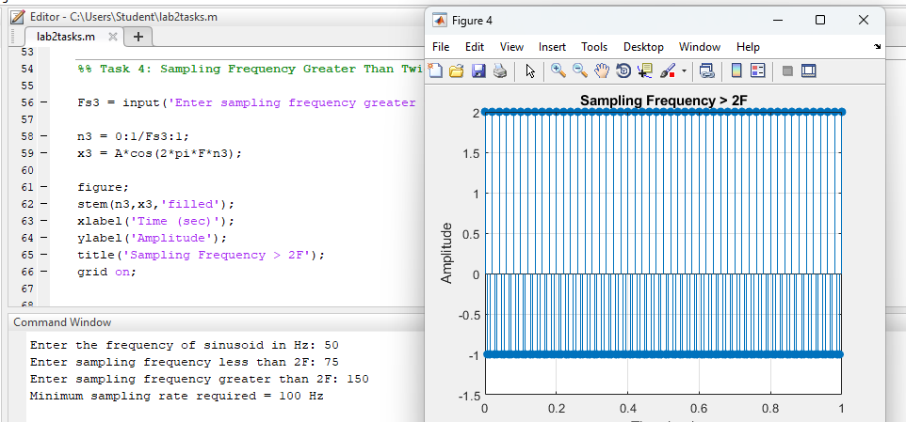

Task 5: Write a script using subplot command to generate task #1, task#2, task#3 and task#4
plots. Analyze the four plots, what happen by increasing the sampling frequency? Write down
your comments
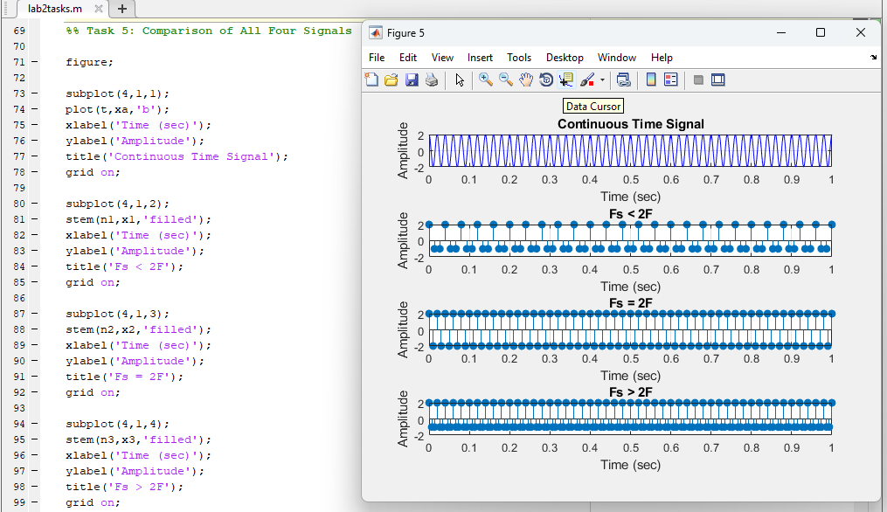

Task6: Consider the analog signal: xa(t) = 3 cos(100πt)
• Determine the minimum sampling rate required to avoid aliasing.
• Suppose that the signal is sampled at the rate Fs=200 Hz. What is the discrete time signal
obtained after sampling? Plot the discrete-time signal.
• Suppose that the signal is sampled at the rate Fs=75 Hz. What is the discrete time signal
obtained after sampling? Plot the discrete-time signal.
